[1.5,0.3,1]

1 run......

Downloading: 100%

411/411 [00:00<00:00, 14.7kB/s]

Downloading: 100%

263M/263M [00:08<00:00, 29.1MB/s]

training 1 epoch...

510.6629388332367 seconds used......

1 training finished! average train loss: 0.44542076972298206

evaluating...

Confusion matrix, without normalization

[[ 155 111 28]

[ 164 3540 117]

[ 9 25 808]]

Normalized confusion matrix

[[0.52721088 0.37755102 0.0952381 ]

[0.0429207 0.92645904 0.03062026]

[0.01068884 0.02969121 0.95961995]]

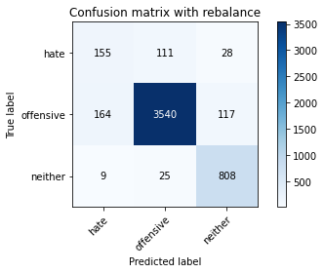

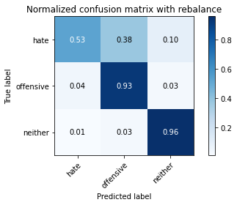

precision recall f1-score support

hate 0.47 0.53 0.50 294

offensive 0.96 0.93 0.94 3821

neither 0.85 0.96 0.90 842

accuracy 0.91 4957

macro avg 0.76 0.80 0.78 4957

weighted avg 0.91 0.91 0.91 4957

average eval_loss: 0.36581763841452136, accuracy: 0.9084123461771233

training 2 epoch...

510.38258838653564 seconds used......

2 training finished! average train loss: 0.3142224787828332

evaluating...

Confusion matrix, without normalization

[[ 194 83 17]

[ 339 3371 111]

[ 29 16 797]]

Normalized confusion matrix

[[0.65986395 0.28231293 0.05782313]

[0.08872023 0.88222978 0.02904999]

[0.03444181 0.01900238 0.94655582]]

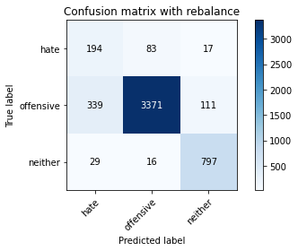

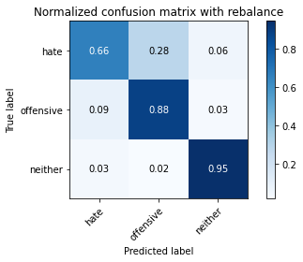

precision recall f1-score support

hate 0.35 0.66 0.45 294

offensive 0.97 0.88 0.92 3821

neither 0.86 0.95 0.90 842

accuracy 0.88 4957

macro avg 0.73 0.83 0.76 4957

weighted avg 0.92 0.88 0.89 4957

average eval_loss: 0.3673034475725745, accuracy: 0.8799677224127497

training 3 epoch...

510.60020422935486 seconds used......

3 training finished! average train loss: 0.21187155728787935

evaluating...

Confusion matrix, without normalization

[[ 192 84 18]

[ 391 3334 96]

[ 27 47 768]]

Normalized confusion matrix

[[0.65306122 0.28571429 0.06122449]

[0.10232923 0.87254645 0.02512431]

[0.03206651 0.05581948 0.91211401]]

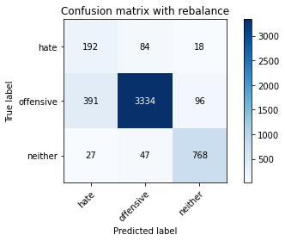

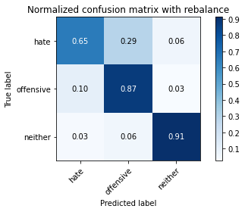

precision recall f1-score support

hate 0.31 0.65 0.42 294

offensive 0.96 0.87 0.92 3821

neither 0.87 0.91 0.89 842

accuracy 0.87 4957

macro avg 0.72 0.81 0.74 4957

weighted avg 0.91 0.87 0.88 4957

average eval_loss: 0.42840571210704625, accuracy: 0.8662497478313496

training 4 epoch...

510.80620408058167 seconds used......

4 training finished! average train loss: 0.12719570177033612

evaluating...

Confusion matrix, without normalization

[[ 164 113 17]

[ 239 3498 84]

[ 20 63 759]]

Normalized confusion matrix

[[0.55782313 0.38435374 0.05782313]

[0.06254907 0.91546716 0.02198377]

[0.02375297 0.07482185 0.90142518]]

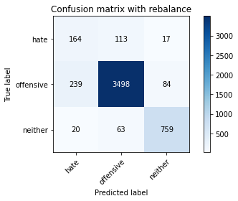

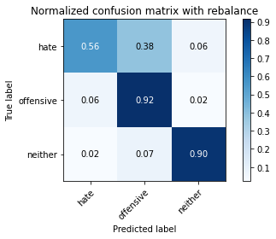

precision recall f1-score support

hate 0.39 0.56 0.46 294

offensive 0.95 0.92 0.93 3821

neither 0.88 0.90 0.89 842

accuracy 0.89 4957

macro avg 0.74 0.79 0.76 4957

weighted avg 0.91 0.89 0.90 4957

average eval_loss: 0.5529111307297435, accuracy: 0.8918700827113173

training 5 epoch...

510.7346498966217 seconds used......

5 training finished! average train loss: 0.06575946434983757

evaluating...

Confusion matrix, without normalization

[[ 117 159 18]

[ 153 3579 89]

[ 17 65 760]]

Normalized confusion matrix

[[0.39795918 0.54081633 0.06122449]

[0.04004187 0.93666579 0.02329233]

[0.02019002 0.07719715 0.90261283]]

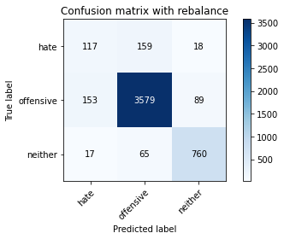

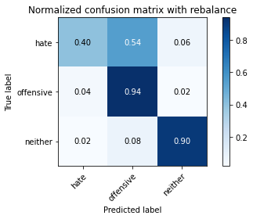

precision recall f1-score support

hate 0.41 0.40 0.40 294

offensive 0.94 0.94 0.94 3821

neither 0.88 0.90 0.89 842

accuracy 0.90 4957

macro avg 0.74 0.75 0.74 4957

weighted avg 0.90 0.90 0.90 4957

average eval_loss: 0.766927092967601, accuracy: 0.898930804922332

2 run......

training 1 epoch...

511.03814005851746 seconds used......

1 training finished! average train loss: 0.44080670277077344

evaluating...

Confusion matrix, without normalization

[[ 211 54 29]

[ 612 3085 124]

[ 30 15 797]]

Normalized confusion matrix

[[0.71768707 0.18367347 0.09863946]

[0.1601675 0.80738027 0.03245224]

[0.03562945 0.01781473 0.94655582]]

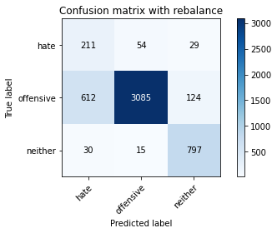

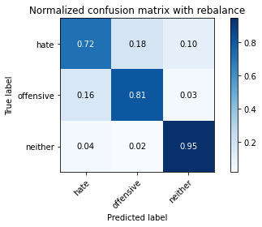

precision recall f1-score support

hate 0.25 0.72 0.37 294

offensive 0.98 0.81 0.88 3821

neither 0.84 0.95 0.89 842

accuracy 0.83 4957

macro avg 0.69 0.82 0.71 4957

weighted avg 0.91 0.83 0.85 4957

average eval_loss: 0.38655900531598636, accuracy: 0.8257010288480936

training 2 epoch...

511.03721141815186 seconds used......

2 training finished! average train loss: 0.31188071374180576

evaluating...

Confusion matrix, without normalization

[[ 173 84 37]

[ 221 3452 148]

[ 8 18 816]]

Normalized confusion matrix

[[0.58843537 0.28571429 0.12585034]

[0.05783826 0.90342842 0.03873332]

[0.00950119 0.02137767 0.96912114]]

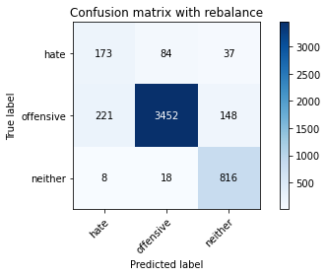

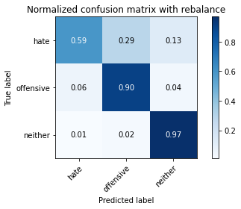

precision recall f1-score support

hate 0.43 0.59 0.50 294

offensive 0.97 0.90 0.94 3821

neither 0.82 0.97 0.89 842

accuracy 0.90 4957

macro avg 0.74 0.82 0.77 4957

weighted avg 0.91 0.90 0.90 4957

average eval_loss: 0.4060096371573426, accuracy: 0.8959047811176114

training 3 epoch...

511.48473715782166 seconds used......

3 training finished! average train loss: 0.2184367527811593

evaluating...

Confusion matrix, without normalization

[[ 215 62 17]

[ 516 3215 90]

[ 38 27 777]]

Normalized confusion matrix

[[0.73129252 0.21088435 0.05782313]

[0.13504318 0.84140277 0.02355404]

[0.04513064 0.03206651 0.92280285]]

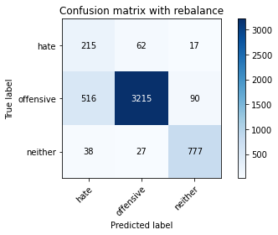

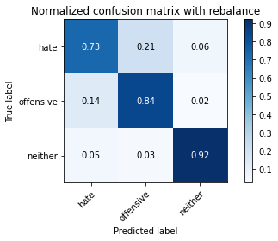

precision recall f1-score support

hate 0.28 0.73 0.40 294

offensive 0.97 0.84 0.90 3821

neither 0.88 0.92 0.90 842

accuracy 0.85 4957

macro avg 0.71 0.83 0.74 4957

weighted avg 0.92 0.85 0.87 4957

average eval_loss: 0.4499956131199255, accuracy: 0.8486988097639702

training 4 epoch...

511.33331203460693 seconds used......

4 training finished! average train loss: 0.13660153687904372

evaluating...

Confusion matrix, without normalization

[[ 150 125 19]

[ 232 3500 89]

[ 17 52 773]]

Normalized confusion matrix

[[0.51020408 0.42517007 0.06462585]

[0.06071709 0.91599058 0.02329233]

[0.02019002 0.06175772 0.91805226]]

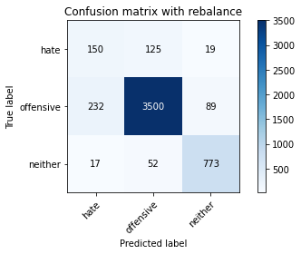

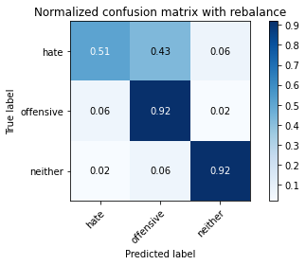

precision recall f1-score support

hate 0.38 0.51 0.43 294

offensive 0.95 0.92 0.93 3821

neither 0.88 0.92 0.90 842

accuracy 0.89 4957

macro avg 0.74 0.78 0.75 4957

weighted avg 0.91 0.89 0.90 4957

average eval_loss: 0.559641294225472, accuracy: 0.8922735525519467

training 5 epoch...

511.3523166179657 seconds used......

5 training finished! average train loss: 0.07851947154561076

evaluating...

Confusion matrix, without normalization

[[ 155 121 18]

[ 198 3544 79]

[ 14 51 777]]

Normalized confusion matrix

[[0.52721088 0.41156463 0.06122449]

[0.0518189 0.92750589 0.02067522]

[0.01662708 0.06057007 0.92280285]]

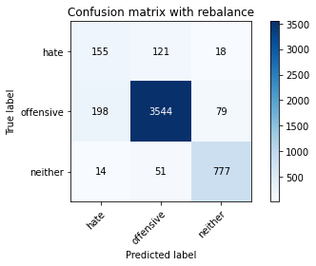

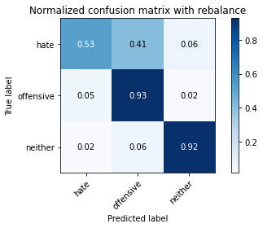

precision recall f1-score support

hate 0.42 0.53 0.47 294

offensive 0.95 0.93 0.94 3821

neither 0.89 0.92 0.91 842

accuracy 0.90 4957

macro avg 0.76 0.79 0.77 4957

weighted avg 0.91 0.90 0.91 4957

average eval_loss: 0.6339282435008264, accuracy: 0.9029655033286262

3 run......

training 1 epoch...

511.0767297744751 seconds used......

1 training finished! average train loss: 0.45061559624774683

evaluating...

Confusion matrix, without normalization

[[ 188 84 22]

[ 291 3442 88]

[ 44 31 767]]

Normalized confusion matrix

[[0.63945578 0.28571429 0.07482993]

[0.07615807 0.90081131 0.02303062]

[0.05225653 0.0368171 0.91092637]]

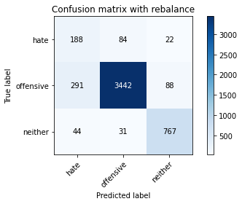

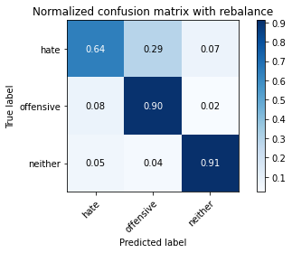

precision recall f1-score support

hate 0.36 0.64 0.46 294

offensive 0.97 0.90 0.93 3821

neither 0.87 0.91 0.89 842

accuracy 0.89 4957

macro avg 0.73 0.82 0.76 4957

weighted avg 0.92 0.89 0.90 4957

average eval_loss: 0.39854617700761846, accuracy: 0.8870284446237644

training 2 epoch...

510.67087507247925 seconds used......

2 training finished! average train loss: 0.31401977242503853

evaluating...

Confusion matrix, without normalization

[[ 185 91 18]

[ 244 3486 91]

[ 33 27 782]]

Normalized confusion matrix

[[0.6292517 0.30952381 0.06122449]

[0.06385763 0.91232662 0.02381576]

[0.0391924 0.03206651 0.92874109]]

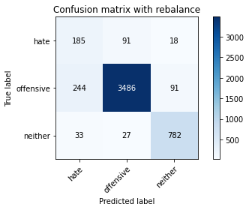

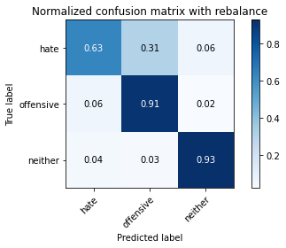

precision recall f1-score support

hate 0.40 0.63 0.49 294

offensive 0.97 0.91 0.94 3821

neither 0.88 0.93 0.90 842

accuracy 0.90 4957

macro avg 0.75 0.82 0.78 4957

weighted avg 0.92 0.90 0.91 4957

average eval_loss: 0.3826813776226294, accuracy: 0.898325600161388

training 3 epoch...

510.29594707489014 seconds used......

3 training finished! average train loss: 0.21540648806718132

evaluating...

Confusion matrix, without normalization

[[ 177 99 18]

[ 240 3483 98]

[ 20 48 774]]

Normalized confusion matrix

[[0.60204082 0.33673469 0.06122449]

[0.06281078 0.91154148 0.02564774]

[0.02375297 0.05700713 0.9192399 ]]

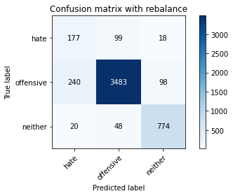

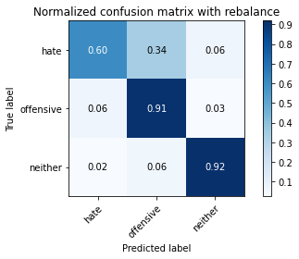

precision recall f1-score support

hate 0.41 0.60 0.48 294

offensive 0.96 0.91 0.93 3821

neither 0.87 0.92 0.89 842

accuracy 0.89 4957

macro avg 0.74 0.81 0.77 4957

weighted avg 0.91 0.89 0.90 4957

average eval_loss: 0.45084663058984126, accuracy: 0.8944926366754085

training 4 epoch...

510.093829870224 seconds used......

4 training finished! average train loss: 0.13033604333219456

evaluating...

Confusion matrix, without normalization

[[ 193 85 16]

[ 362 3358 101]

[ 22 56 764]]

Normalized confusion matrix

[[0.65646259 0.28911565 0.05442177]

[0.0947396 0.87882753 0.02643287]

[0.02612827 0.06650831 0.90736342]]

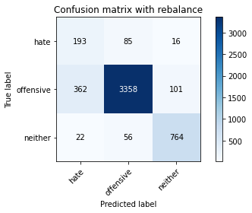

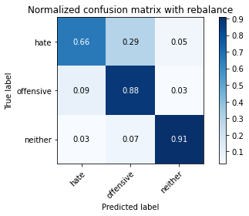

precision recall f1-score support

hate 0.33 0.66 0.44 294

offensive 0.96 0.88 0.92 3821

neither 0.87 0.91 0.89 842

accuracy 0.87 4957

macro avg 0.72 0.81 0.75 4957

weighted avg 0.91 0.87 0.88 4957

average eval_loss: 0.504093439057244, accuracy: 0.8704861811579584

training 5 epoch...

509.91340041160583 seconds used......

5 training finished! average train loss: 0.07425688860647854

evaluating...

Confusion matrix, without normalization

[[ 146 132 16]

[ 138 3601 82]

[ 25 66 751]]

Normalized confusion matrix

[[0.49659864 0.44897959 0.05442177]

[0.0361162 0.94242345 0.02146035]

[0.02969121 0.0783848 0.89192399]]

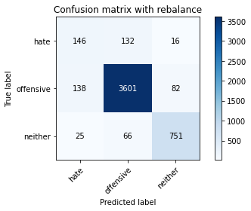

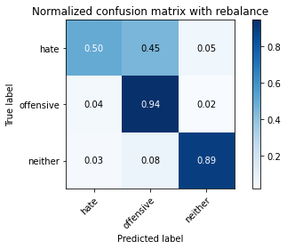

precision recall f1-score support

hate 0.47 0.50 0.48 294

offensive 0.95 0.94 0.95 3821

neither 0.88 0.89 0.89 842

accuracy 0.91 4957

macro avg 0.77 0.78 0.77 4957

weighted avg 0.91 0.91 0.91 4957

average eval_loss: 0.7071949490465715, accuracy: 0.9074036715755497

4 run......

training 1 epoch...

510.3398549556732 seconds used......

1 training finished! average train loss: 0.45546525039695085

evaluating...

Confusion matrix, without normalization

[[ 171 100 23]

[ 229 3481 111]

[ 26 16 800]]

Normalized confusion matrix

[[0.58163265 0.34013605 0.07823129]

[0.05993195 0.91101806 0.02904999]

[0.03087886 0.01900238 0.95011876]]

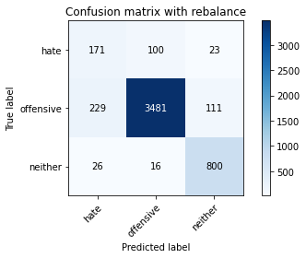

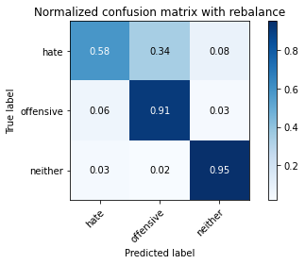

precision recall f1-score support

hate 0.40 0.58 0.48 294

offensive 0.97 0.91 0.94 3821

neither 0.86 0.95 0.90 842

accuracy 0.90 4957

macro avg 0.74 0.81 0.77 4957

weighted avg 0.92 0.90 0.90 4957

average eval_loss: 0.36327250204199263, accuracy: 0.8981238652410732

training 2 epoch...

510.3695411682129 seconds used......

2 training finished! average train loss: 0.3172028157231022

evaluating...

Confusion matrix, without normalization

[[ 193 86 15]

[ 325 3417 79]

[ 52 35 755]]

Normalized confusion matrix

[[0.65646259 0.29251701 0.05102041]

[0.08505627 0.89426852 0.02067522]

[0.06175772 0.0415677 0.89667458]]

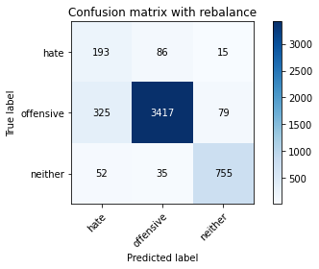

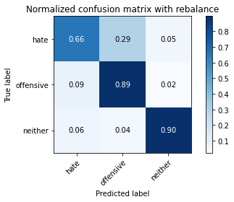

precision recall f1-score support

hate 0.34 0.66 0.45 294

offensive 0.97 0.89 0.93 3821

neither 0.89 0.90 0.89 842

accuracy 0.88 4957

macro avg 0.73 0.82 0.76 4957

weighted avg 0.92 0.88 0.89 4957

average eval_loss: 0.39809360699878343, accuracy: 0.8805729271736937

training 3 epoch...

510.379714012146 seconds used......

3 training finished! average train loss: 0.21683776622446585

evaluating...

Confusion matrix, without normalization

[[ 158 113 23]

[ 195 3520 106]

[ 19 39 784]]

Normalized confusion matrix

[[0.53741497 0.38435374 0.07823129]

[0.05103376 0.92122481 0.02774143]

[0.02256532 0.04631829 0.93111639]]

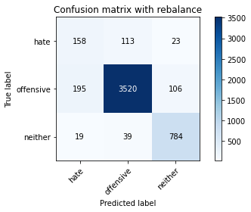

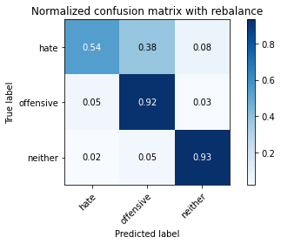

precision recall f1-score support

hate 0.42 0.54 0.47 294

offensive 0.96 0.92 0.94 3821

neither 0.86 0.93 0.89 842

accuracy 0.90 4957

macro avg 0.75 0.80 0.77 4957

weighted avg 0.91 0.90 0.90 4957

average eval_loss: 0.4330140205716053, accuracy: 0.9001412144442204

training 4 epoch...

510.85695219039917 seconds used......

4 training finished! average train loss: 0.12912368430742419

evaluating...

Confusion matrix, without normalization

[[ 160 116 18]

[ 253 3464 104]

[ 35 44 763]]

Normalized confusion matrix

[[0.54421769 0.39455782 0.06122449]

[0.06621303 0.90656896 0.02721801]

[0.0415677 0.05225653 0.90617577]]

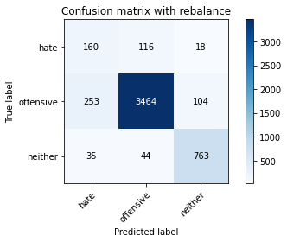

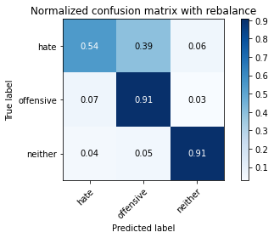

precision recall f1-score support

hate 0.36 0.54 0.43 294

offensive 0.96 0.91 0.93 3821

neither 0.86 0.91 0.88 842

accuracy 0.89 4957

macro avg 0.73 0.79 0.75 4957

weighted avg 0.90 0.89 0.89 4957

average eval_loss: 0.5639903653584863, accuracy: 0.8850110954206173

training 5 epoch...

510.68875074386597 seconds used......

5 training finished! average train loss: 0.08029561325765239

evaluating...

Confusion matrix, without normalization

[[ 158 121 15]

[ 242 3510 69]

[ 25 72 745]]

Normalized confusion matrix

[[0.53741497 0.41156463 0.05102041]

[0.06333421 0.91860769 0.0180581 ]

[0.02969121 0.08551069 0.8847981 ]]

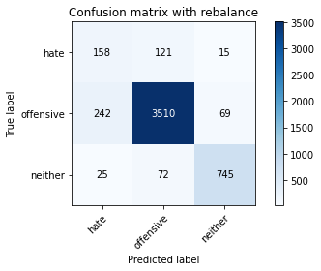

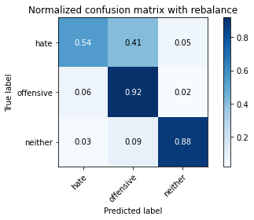

precision recall f1-score support

hate 0.37 0.54 0.44 294

offensive 0.95 0.92 0.93 3821

neither 0.90 0.88 0.89 842

accuracy 0.89 4957

macro avg 0.74 0.78 0.75 4957

weighted avg 0.91 0.89 0.90 4957

average eval_loss: 0.6667457609446794, accuracy: 0.8902562033487996

5 run......

training 1 epoch...

510.80163621902466 seconds used......

1 training finished! average train loss: 0.44451325005596326

evaluating...

Confusion matrix, without normalization

[[ 201 67 26]

[ 470 3224 127]

[ 25 13 804]]

Normalized confusion matrix

[[0.68367347 0.22789116 0.08843537]

[0.12300445 0.84375818 0.03323737]

[0.02969121 0.01543943 0.95486936]]

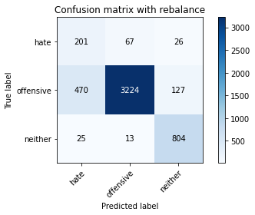

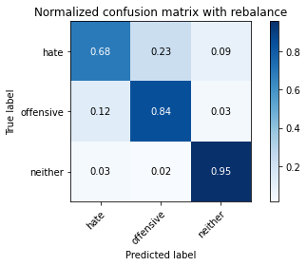

precision recall f1-score support

hate 0.29 0.68 0.41 294

offensive 0.98 0.84 0.90 3821

neither 0.84 0.95 0.89 842

accuracy 0.85 4957

macro avg 0.70 0.83 0.73 4957

weighted avg 0.91 0.85 0.87 4957

average eval_loss: 0.39566816349003103, accuracy: 0.8531369780108937

training 2 epoch...

510.5605835914612 seconds used......

2 training finished! average train loss: 0.3103797113421493

evaluating...

Confusion matrix, without normalization

[[ 196 79 19]

[ 313 3403 105]

[ 25 35 782]]

Normalized confusion matrix

[[0.66666667 0.26870748 0.06462585]

[0.08191573 0.89060455 0.02747972]

[0.02969121 0.0415677 0.92874109]]

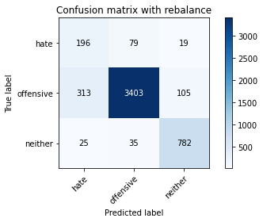

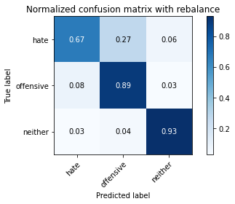

precision recall f1-score support

hate 0.37 0.67 0.47 294

offensive 0.97 0.89 0.93 3821

neither 0.86 0.93 0.89 842

accuracy 0.88 4957

macro avg 0.73 0.83 0.77 4957

weighted avg 0.91 0.88 0.90 4957

average eval_loss: 0.3794277838221, accuracy: 0.8838006858987291

training 3 epoch...

510.1259768009186 seconds used......

3 training finished! average train loss: 0.2171882426529567

evaluating...

Confusion matrix, without normalization

[[ 194 80 20]

[ 294 3413 114]

[ 37 27 778]]

Normalized confusion matrix

[[0.65986395 0.27210884 0.06802721]

[0.07694321 0.89322167 0.02983512]

[0.04394299 0.03206651 0.9239905 ]]

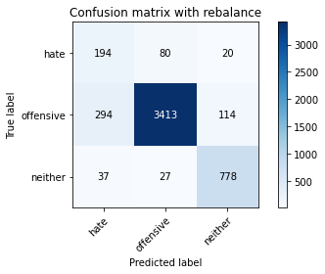

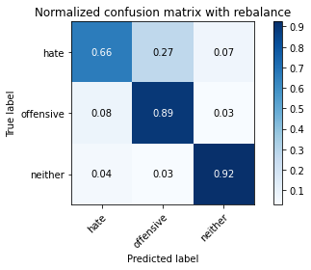

precision recall f1-score support

hate 0.37 0.66 0.47 294

offensive 0.97 0.89 0.93 3821

neither 0.85 0.92 0.89 842

accuracy 0.88 4957

macro avg 0.73 0.83 0.76 4957

weighted avg 0.91 0.88 0.90 4957

average eval_loss: 0.4093137853403365, accuracy: 0.8846076255799878

training 4 epoch...

510.6885507106781 seconds used......

4 training finished! average train loss: 0.14183486906392406

evaluating...

Confusion matrix, without normalization

[[ 157 118 19]

[ 188 3550 83]

[ 12 72 758]]

Normalized confusion matrix

[[0.53401361 0.40136054 0.06462585]

[0.04920178 0.92907616 0.02172206]

[0.01425178 0.08551069 0.90023753]]

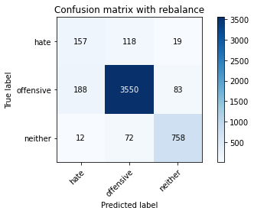

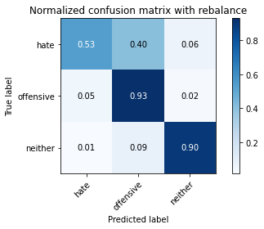

precision recall f1-score support

hate 0.44 0.53 0.48 294

offensive 0.95 0.93 0.94 3821

neither 0.88 0.90 0.89 842

accuracy 0.90 4957

macro avg 0.76 0.79 0.77 4957

weighted avg 0.91 0.90 0.90 4957

average eval_loss: 0.5064688249662023, accuracy: 0.9007464192051644

training 5 epoch...

510.3944821357727 seconds used......

5 training finished! average train loss: 0.08436697548202046

evaluating...

Confusion matrix, without normalization

[[ 139 139 16]

[ 198 3554 69]

[ 16 94 732]]

Normalized confusion matrix

[[0.47278912 0.47278912 0.05442177]

[0.0518189 0.930123 0.0180581 ]

[0.01900238 0.11163895 0.86935867]]

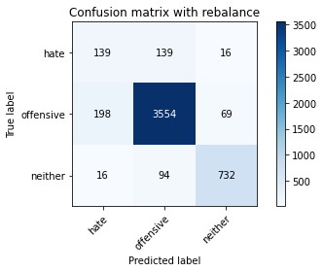

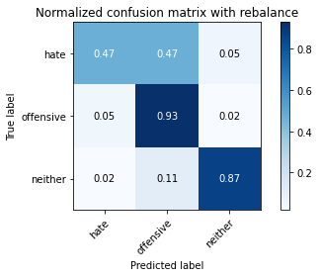

precision recall f1-score support

hate 0.39 0.47 0.43 294

offensive 0.94 0.93 0.93 3821

neither 0.90 0.87 0.88 842

accuracy 0.89 4957

macro avg 0.74 0.76 0.75 4957

weighted avg 0.90 0.89 0.90 4957

average eval_loss: 0.6304355793897318, accuracy: 0.8926770223925762